----------------------------------------------------------------------------------NAME:T.SUMANTH MUKESH ROLLNO:AP25110011022 SECTION:CSE CORE-A DATE-06-08-2026
----------------------------------------------------------------------------
LINEAR SEARCH :
CODE:
#include <stdio.h>
int linearSearch(int arr[], int size, int target) {
for (int i = 0; i < size; i++) {
if (arr[i] == target) {
return i; }
}
return 0;
}
int main() {
int size = 6, target, result;
int arr[] = {12, 45,10, 19, 28, 32};
printf("Enter the number to search: ");
scanf("%d", &target);
result = linearSearch(arr, size, target);
if (result != 0) {
printf("Element %d found at index position %d\n", target, result);
} else {
printf("Element not found in the array.\n");
}
return 0;
}
OUTPUT :
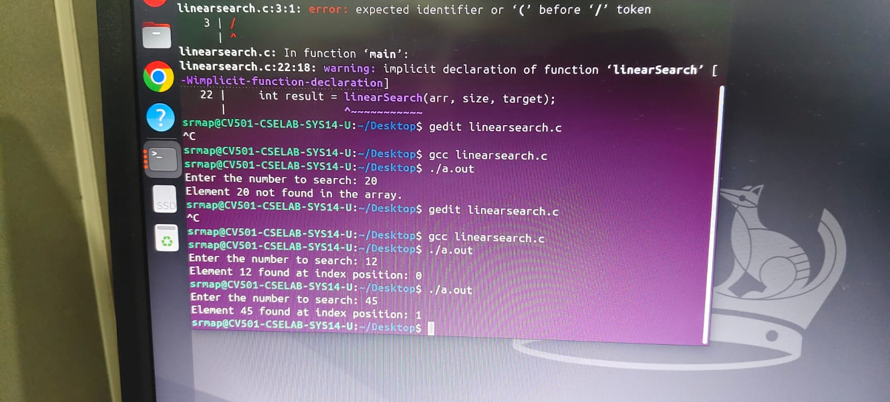

BINARY SEARCH :
CODE:
int binarySearch(int arr[], int size, int target) {
int low = 0;
int high = size - 1;
while (low <= high) {
int mid = low + (high - low) / 2;
if (arr[mid] == target) {
return mid;
}
else if (arr[mid] < target) {
low = mid + 1; }
else {
high = mid - 1;
}
}
return 0; }
int main() {
int arr[] = {2, 5, 8, 12, 16, 23, 38, 56, 72, 91};
int size = 10;
int target ;
scanf("%d",&target);
int result = binarySearch(arr, size, target);
if (result != 0) {
printf("Element %d found at index %d.\n", target, result);
} else {
printf("Element %d not found in the array.\n", target); }
return 0;}
OUTPUT:
